BMP Project Fact Sheet
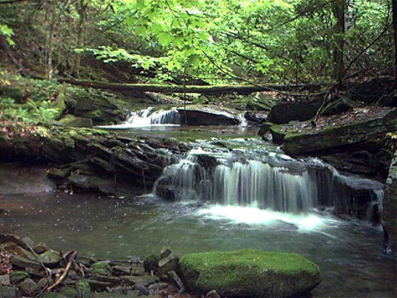
(Insert Title of BMP Here)
Use this part of the page to provide details about the BMP such as:
- Location
- Project/BMP Description
- Drainage Area Characteristics/Size
- Design Considerations
- Site Soil Conditions
- Special Site-Specific Requirements
- Water Quality Benefits
- Water Quantity Benefits
- Groundwater Recharge Benefits
- Permitting Requirements
- Operations and Maintenance Requirements
- Cost
- Hyperlink for more information about project

Contact Information – Use this text box to enter phone/email of project owner, designer and/or other project partners
Did you know…..Use this text box with alternative font to provide interesting information about the BMP, such as lessons learned, special maintenance concerns or monitoring data.

