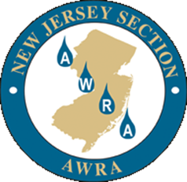 | NEW JERSEY SECTION AMERICAN WATER RESOURCES ASSOCIATION  11th Annual  Excellence in Water Resources Protection and Planning Award  Application Form

- Applicant Name: E-Mail:
Address: Daytime Phone: Ext.
City/State: Zip Code Cell Phone:

- Project Owner: E-mail:

Address: Daytime Phone: Ext.

City/State: Zip Code Cell Phone:
- Project Name: Address/Location:
Municipality: County: Zip Code
- Additional Partners:
(include name,
Organization,
email, phone#)

- Project Type: (select one)
- ☐ Stormwater Management ☐ Groundwater ☐ Ecological Restoration ☐ Water Resources Planning
Application Checklist
☐ Part A: Completed application form;
☐ Part B: A description of the project including the following:
☐ Location of project;
☐ Project purpose and need;
☐ Project description/improvements; and
☐ Schedule.
☐ Part C: Narrative addressing how the project meets the award criteria including the following:
☐ Demonstration of innovative and effective approach to water resources management or planning;
☐ Discussion of partnerships among multiple stakeholders, such as government representatives (state, county, local), nonprofits and private entities; and
☐ How the project embodies the mission of the NJ Section and National AWRA. (https://njawra.org/About)
☐ Part D: If appropriate, photographs, maps and/or drawings of the project (encouraged)

